Matoshri College of Engineering and Research Center
Eklahare ,Nashik

REPORT
ON
“Farmer Management System”

Submitted by

SAGAR PRAVIN SAPKALE

YASH YUVRAJ SHELKE

GIRIJ SHYAM VISPUTE

PRASAD SOMNATH WAKCHAURE

SUMEDH GAUTAM JADHAV

DEPARTMENT OF ELECTRONICS AND COMPUTER ENGINEERING

YEAR 2025-2026
Matoshri College of Engineering and Research Center
Eklahare ,NashiK

CERTIFICATE

This is to certify that the project work entitled “Farmer Management System”, has been successfully completed during the academic year of 2025-2026 by the following students:
1. SAGAR PRRAVIN SAPKALE
2. YASH YUVRAJ SHELKE
3. IRIJ SHYAM VISPUTE
4. PRASAD SOMNATH WAKCHAURE
5. SUMEDH GAUTAM JADHAV

This project conforms to the standards laid down by SPPU and has been completed in satisfactory manner as a partial fulfillment for the bachelor‘s degree in Electronics Engineering, SPPU.

Prof.N.B.AHER Dr. J.J.CHOPDE Dr. G.K.Kharate
Project Guide H.O.D. Principal

CONTENTS

Chapter No. | TITLE | Page No.
 | Introduction | 4
 | Review | 5
 | ER-Diagram | 6
 | Screenshots | 7-10

INTRODUCTION

Chapter 1: Introduction
Overview
The Farmer Management System (FMS) is a computer-based project that helps manage all the activities related to farmers and their farms. It is designed to store and organize information about farmers, their land, crops, fertilizers, and sales.
In earlier days, farmers used notebooks or registers to record their data, which could easily get lost or damaged. This project aims to make their work easier by using a digital system where all information can be saved safely and accessed anytime.

Objectives

The main goals of this system are:
- To help farmers keep their data in one place.
- To make it easier to record details about crops, land, and sales.
- To save time and reduce paperwork.
- To generate reports automatically.
- To support better decision-making for farmers and administrators.

Scope

This system can be used by:
Farmers: to store their crop and land information.
Administrators: to manage all farmers’ data and view reports.
In the future, this system can also be connected to weather data or mobile apps to make it more advanced.

Chapter 2: Review

2.1 Existing System
Currently, most farmers record their data manually in notebooks. This process takes time and may lead to mistakes or data loss. It is also difficult to find specific information when needed.

2.2 Proposed System
The proposed Farmer Management System makes all these tasks automatic. It stores farmer details, crop information, sales data, and fertilizer usage in a database. Users can easily search or update records, and administrators can view overall reports.
This system improves accuracy, saves time, and helps farmers make better decisions.

2.3 Advantages
- Saves time and effort
- Easy to use
- Reduces paper usage
- Data is safe and easy to access
- Helps generate useful reports

Category | Details
Operating System | Windows 10 / 11
Programming Language | Python (Flask )
Database | MySQL
Web Browser | Chrome, Firefox, Edge
Tools / IDE | Visual Studio Code
Other Dependencies | HTML, CSS, JavaScript

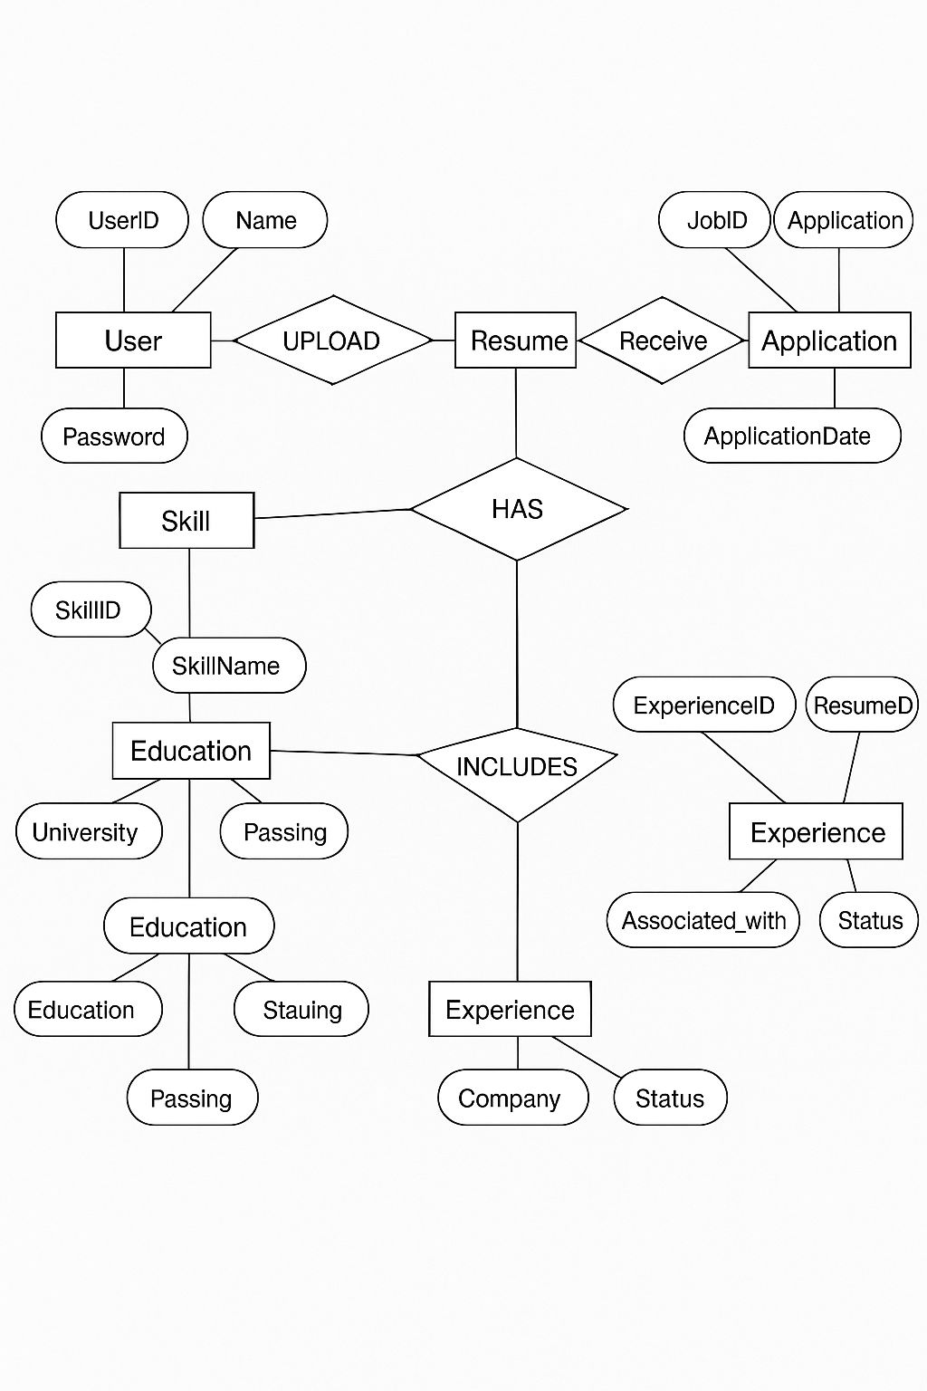
ER-DIAGRAM

Chapter 4: Screenshots
4.1 Home Page

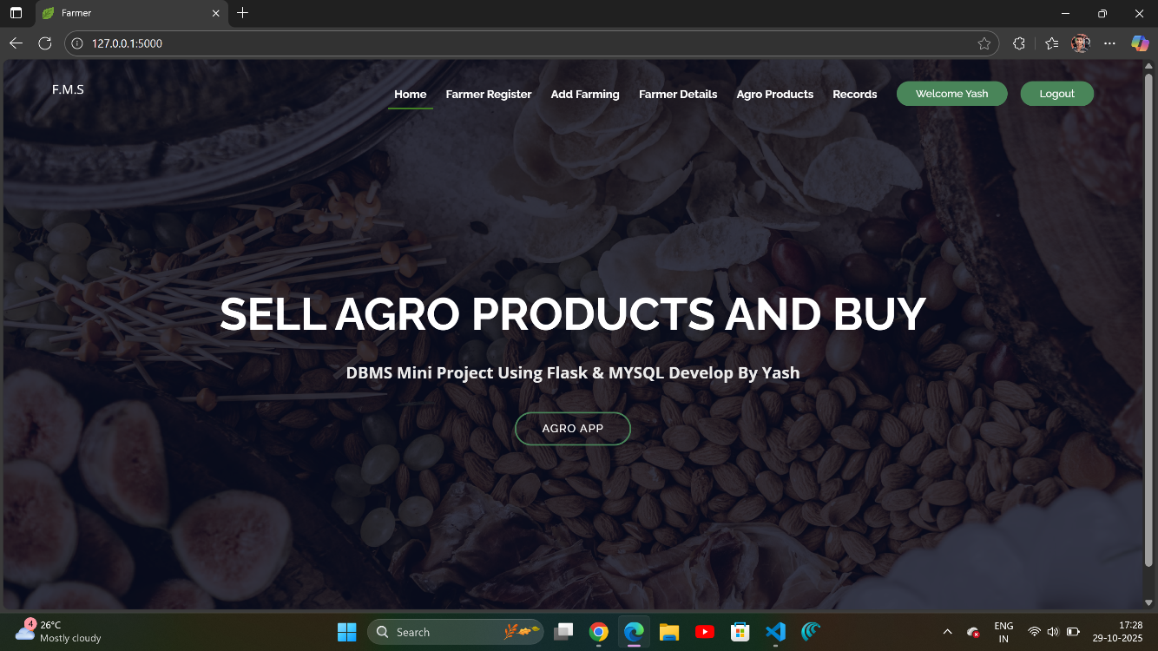
This is the main page of the system. From here, users can go to other sections like farmer details, crops, and sales.

4.2 Farmer Registration Page

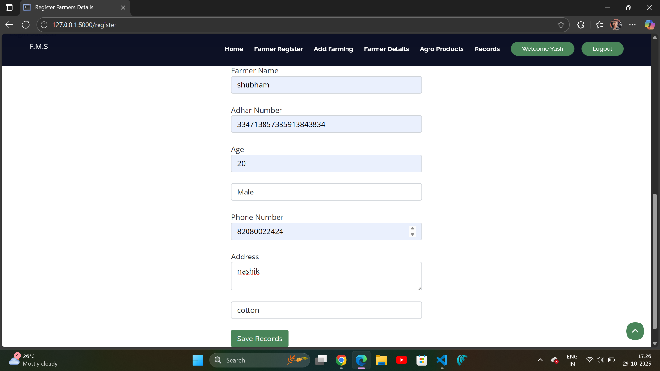
This page allows users to add new farmers by entering their name, contact number, and land details.

4.3 Farming Add Page

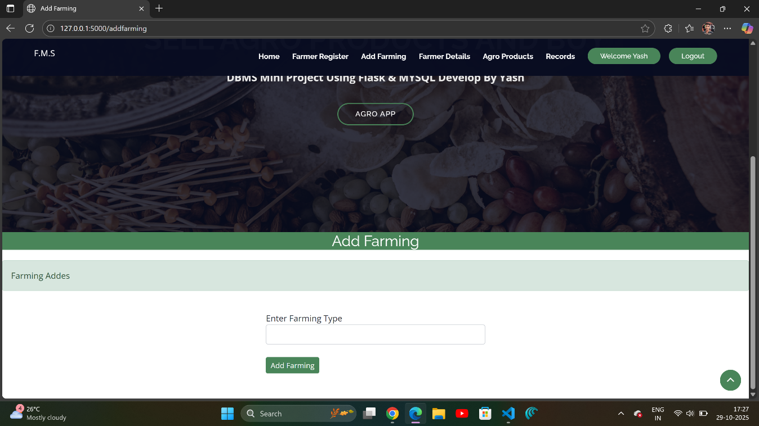
This is the Farming Add Page, where users can enter new farming or crop details.

4.4 Farmer Details

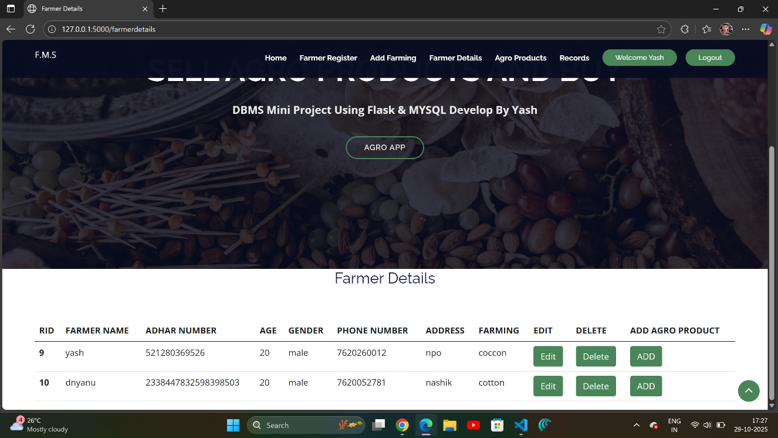
This page shows a complete list of all farmers registered in the system.

4.5 Agro Products Page

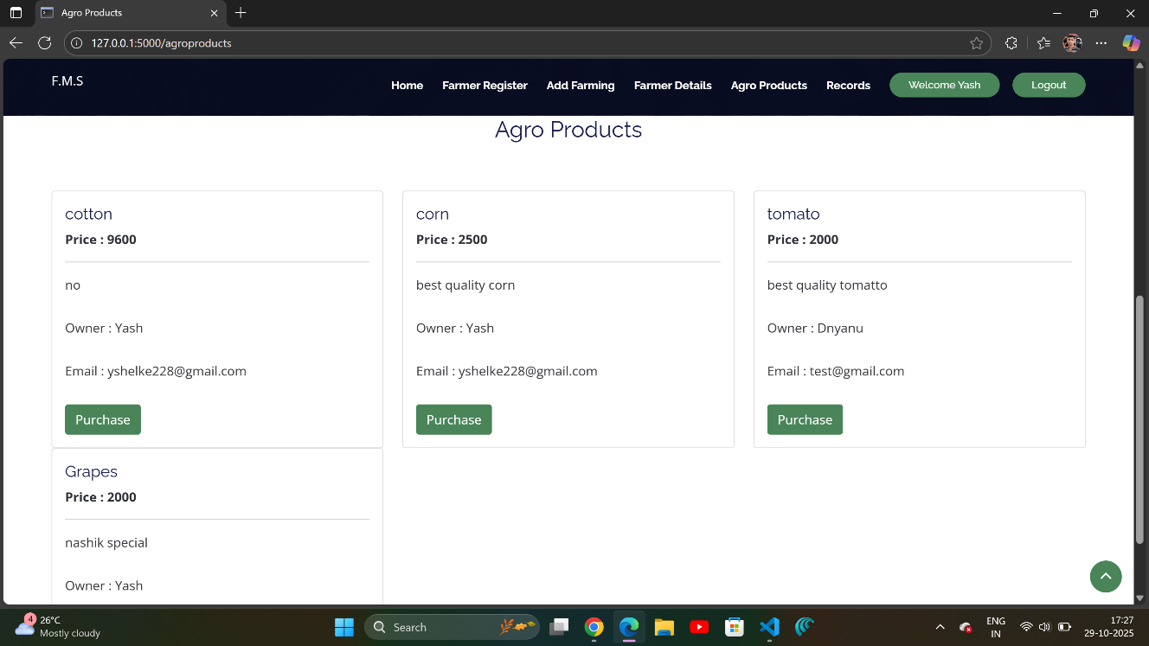This page displays information about different agricultural products used or sold by farmers.

